RUNGE-KUTTA METHOD:
INTRODUCTION:
To solve = f(x,y) given y(x₀) = y₀ -------(1)
By Taylor series, we have,
y(x+h) = y(x) +h y’(x) + 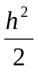y’’(x) + O(h³) -------(2)
Differentiating the equation (1) w.r.t. x,
y’’ = 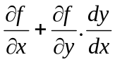 = f_{x}+y’f_{y} = f_{x}+ff_{y} --------(3)
Using the values of y’ and y’’ got from (1) and (3), in (2), we get,
y(x+h)-y(x) = hf+h²[f_{x}+ff_{y}] + O(h³)
Δy = hf+ h²[f_{x}+ff_{y}] + O(h³) ----------(4)
Let Δ₁y = k₁ = f(x,y).Δx = hf(x,y) ----------(5)
Δ₂y = k₂ = f(x+mh,y+mk₁) ----------(6)
and let Δy = ak₁+bk₂ ----------(7)
where a,b and m are constants to be determined to get the better accuracy of Δy.
Expand k₂ and Δy in powers oh h.
Expanding k₂, by Taylor series for two variables, we have
k₂ = h f(x+mh , y+mk₁)
= h 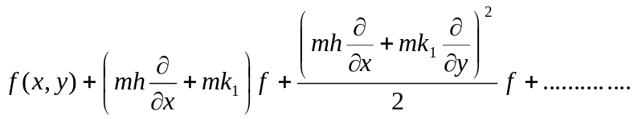
= h 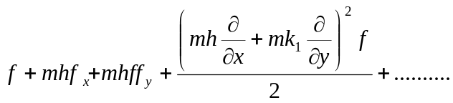 ----------(8)
= hf+mh²(f_{x}+ff_{y}) + ………………. higher powers of h ----------(9)
Substituting k₁, k₂ in (7),
Δy = ahf +b[ hf+mh²(f_{x}+ff_{y}) + O(h³)]
= (a+b) hf + bmh²(f_{x}+ff_{y}) + O(h³) -----------(10)
Equating Δy from (4) and (10), we get
= hf +mh²(f_{x}+ff_{y}) + ………… higher powers of h
a+b = 1 and bm = -----------(11)
Now we have only two equations given by (1) to solve for three unknowns a,b,m.
From a+b = 1, a = 1-b and also m = 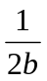using (7),
Δy = (1-b) k₁+bk₂
Where k₁ = hf(x,y)
k₂ = hf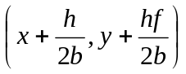
Now Δy = y(x+h) – y(x)
y(x+h) = y(x) + (1-b)hf +bhf
i.e., y_{n+1} = y_{n}+ (1-b)hf(x_{n},y_{n}) + bhf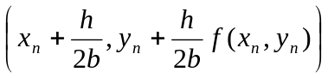+ O(h³)
From this general second order Runge-Kutta formula, setting a = 0, b = 1, m = , we get the second order Runge-Kutta algorithm as
k₁ = hf(x,y)
k₂ = hf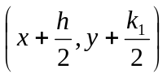
and Δy = k₂ where h = Δx.
Since the derivations of third and fourth order Runge-Kutta algorithms are tedious, we state them below for use.
The third order Runge-Kutta method algorithm is given below
k₁ = hf(x,y)
k₂ = hf
k₃ = hf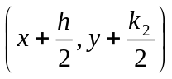
Δy = (k₁+4k₂+k₃)
The fourth order Runge-Kutta method algorithm is mostly used in problems unless otherwise mentioned. It is
k₁ = hf(x,y)
k₂ = hf
k₃ = hf
k₄ = hf(x+h,y+k₃)
Δy = (k₁+2k₂+2k₃+k₄)
y(x+h) = y(x) + Δy.
PROBLEMS:
1.Apply the fourth order Runge-Kutta method to find y(0.1), y(0.2) given that y’ = x+y,
y(0) = 1.
Sol:
Here h = 0.1, x₀ = 0, y₀ = 1, x₁ = 0.1, x₂ = 0.2, f(x,y) = x+y.
Find y₁:
k₁ = hf(x₀, y₀) = (0.1) (x₀+y₀) = (0.1)(0+1) = 0.1
k₂ = hf (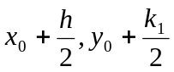) = (0.1)f(0.05,1.05) = (0.1)(0.05+1.05) = 0.11.
k₃ = hf (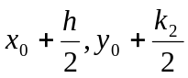) = (0.1) f(0.05, 1.055) = (0.1)(0.05+1.055) = 0.1105
k₄ = hf (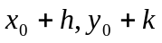) = (0.1) f(0.1, 1.1105) = (0.1)(0.1+1.1105) = 0.12105
Δy = (k₁+ 2k₂ + 2k₃ + k₄) =(0.1+0.22+0.22100.12105) = 0.11034
y₁ ₌ y(0.1) = y₀ + Δy = 1.11034
Find y₂:
k₁ = hf(x₁, y₁) = (0.1) (x₁+y₁) = (0.1)(0.1+1.11034) = 0.12103
k₂ = hf (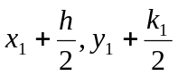) = (0.1)f(0.15, 1.17086) = (0.1)(0.15+1.17086) = 0.13209
k₃ = hf (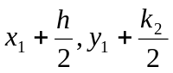) = (0.1) f(0.15,1.17639) = (0.1)(0.15+1.17639) = 0.13264
k₄ = hf (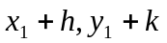) = (0.1) f(0.2, 1.24298) = (0.1)(0.2+1.24298) = 0.14430
Δy = (k₁+ 2k₂ + 2k₃ + k₄) =(0.12103+2x0.13209+2x0.13264+0.14430)
y₂ ₌ y(0.2) = y₁ + Δy = 1.11034+(0.12103+2x0.13209+2x0.13264+0.14430)
= 1.2428.

2.Obtain the values of y at x = 0.1 using Runge-kutta method of fourth order for the differential equation y’ = -y given y(0) = 1.
Sol:
Here h = 0.1, x₀ = 0, y₀ = 1, x₁ = 0.1, x₂ = 0.2, f(x,y) = -y
Find y₁:
k₁ = hf(x₀, y₀) = (0.1) (-y₀) = (0.1)(-1) = -0.1
k₂ = hf () = (0.1)f(0.05,0.95) = -0.095
k₃ = hf () = (0.1) f(0.05, 0.9525) = -0.09525
k₄ = hf () = (0.1) f(0.1, 0.90475) = -0.090475
Δy = (k₁+ 2k₂ + 2k₃ + k₄) =(-0.1+2x-0.095+2x-0.09525-0.090475)
y₁ ₌ y(0.1) = y₀ + Δy = 1+(0.1+2x-0.095+2x-0.09525-0.090475)
= 0.90484

